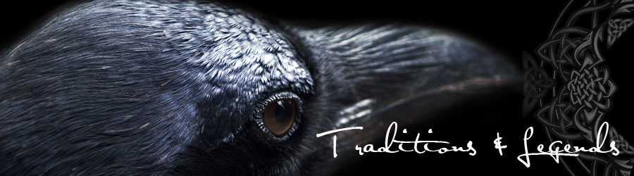
“The Diamond Inside”

Jillian Currie

Ravens Vision
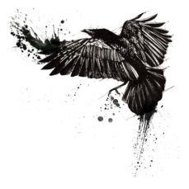
A young boy went to his Grandfather one day and asked him, “Grandfather, what is the value of my life?” The Grandfather did not answer him but instead handed him a stone. He told the boy, “Go to a Market with this stone. If anyone asks you how much the stone is, do not answer them. Only hold up two fingers.”
The boy went on his way to the market. Before long, he was approached by a woman. “What a beautiful stone! I must have this stone for my garden. How much will you sell your stone for?” The boy did not answer. Instead he raised two fingers. “Two dollars,” the women exclaimed, “I will take it!”
The boy raced home to his Grandfather in excitement. “Grandfather! A woman bought my stone for two dollars! Now will you tell me the value of my life?” The Grandfather did not answer him but instead handed him another stone. He told the boy, “Bring this stone to the director at the Museum. If he asks him how much the stone is, do not answer him. Only hold up two fingers.
The boy went to the Museum with his stone. When the boy presented the director his stone the man was overjoyed. “What a special stone! I must have this stone for my Museum so I may share its beauty with others. How much will you sell your stone for?” The boy did not answer. Instead he raised two fingers. “Two thousand dollars,” the man exclaimed, “I will take it!”
Not believing his luck, the boy raced home to his Grandfather. “Grandfather! Grandfather! The Director at the Museum bought my stone for two thousand dollars! Now will you tell me the value of my life?” The Grandfather did not answer him but instead handed him another stone. He told the boy, “Go to the precious gem store with this stone. If the owner asks him how much the stone is, do not answer him. Only hold up two fingers.”
The boy went to the precious gem store and approached the owner. He held out his fist and slowly opened it to reveal the stone nestled safely inside his palm. The owner shouted out in amazement, “my dear boy, where ever did you get that from? It is the rarest stone, the most precious stone in the world. I must have this stone for my precious gem store. How much will you sell your stone for? The boy did not answer. Instead he raised two fingers. “Two hundred thousand dollars,” the man exclaimed, “I will take it!”
The boy ran home to his Grandfather as fast as his feet would take him. “Grandfather! Grandfather! Grandfather! The owner of the precious gem store bought my rock for two hundred thousand dollars!”
The Grandfather turned to the boy and asked, “Grandson, do you know the value of your life now? You see, it doesn’t matter where you come from…where you were born…the color of your skin…or how much money you were born into. It matters where you decide to place yourself…the people you surround yourself with…how you choose to carry yourself. You may have lived your whole life thinking that you were a two dollar stone. You may have lived your whole life surrounded by people that saw your worth for only two dollars. But everybody has a diamond inside of them and we can choose to surround ourselves with people that see our value and see the diamond inside of us. We can choose to put ourselves in a market or put ourselves in a precious gem store. And you can also choose to see the value in other people. You can help other people see the diamond inside them. Chose the people you surround yourself with wisely. That can make all the difference in your life.”

